Association of University Radiologists 57th Annual Meeting
May 12 – 15, 2009
Tues - Fri
Arlington, VA
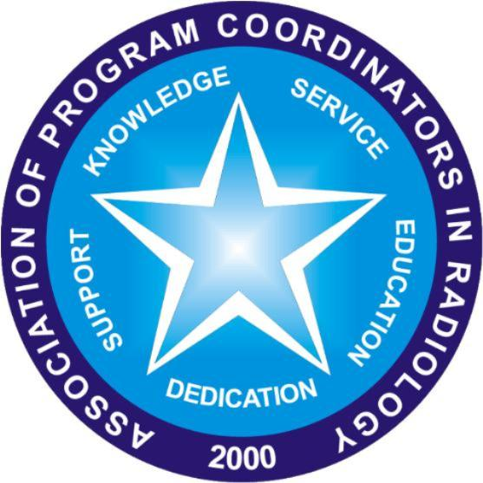
APCR itinerary
DRAFT- Revised 2/23/09

Tuesday, May 12, 2009

Time | Activity |  | Location
Tuesday

Arrival
6:30-8:00am |  | Breakfast – all attendees | Arlington Ballroom Salon 4
7:00-8:30am |  | APCR Board Meeting – Closed session | Fairfax Boardroom
8:30-9:30am |  | APCR Past Presidents Meeting – Closed session | Fairfax Boardroom
8:30-10:00am |  | APDR/APCR Joint Session: Resident Selection 101: The Fundamentals  - Resident selection: Program Director’s point of view  - Resident selection: Program Coordinator’s point of view  - Resident selection: Student Advisor and Medical Student’s point of view | Arlington Ballroom Salon 3
9:30-10:00am |  | APCR Liaison Committee Meeting – Closed session | Fairfax Boardroom
10:30a-12:00pm |  | APDR/APCR Joint Session: Resident Selection 201: The Complex Issues  - Rules of the MATCH  - What Happens if your program doesn’t MATCH  - Resident Selection Panel Discussion | Arlington Ballroom Salon 3
2:00pm-3:30pm |  | APDR/APCR/ACER Joint Session:  Calendar Management | Arlington Ballroom Salon 3
6:00pm-7:00pm |  | Beer and Pretzels Reception  All attendees | Grand Ballroom Salons F/G/H
7:00pm-8:00pm |  | APCR Reception with New Member Welcome Event | Grand Ballroom Salon K

Wednesday, May 13, 2009

Time | Activity |  | Location
Wednesday
6:30a – 8:00am |  | Breakfast – all attendees | Arlington Ballroom Salon 4
8:30a-10:00am |  | APDR Session: ABR Update | Grand Ballroom Salon H
10:30a –12:00pm |  | APCR Business Meeting #1:  All members attend! | Grand Ballroom Salon K
12:00pm-1:45pm |  | AUR Awards Ceremony and Image Interpretation Competition #1 | Arlington Ballroom Salons 1,2,3
2:00pm-3:30pm |  | APDR/RRC/ACGME Update | Grand Ballroom Salons B/C/D/E
4:00pm-5:30pm |  | A3CR2/APDR/APCR/SCARD/ACER: Brogdon Panel: A3CR2 Plans | Grand Ballroom Salons B/C/D/E
6:30pm-8:30pm |  | AUR Welcome Reception  All attendees | Torpedo Factory Art Center

Thursday, May 14, 2009

Time | Activity |  | Location
Thursday
6:30am– 8:00am |  | Breakfast – all attendees | Arlington Ballroom Salon 4
7:00 am-8:15am |  | APCR Session #1: EDUCATION  - What you should learn during residency – Deborah L. Reede, M.D.  - The Fourth year after 2013– Judith K. Amorosa, M.D, FACR  - Portfolios – Nikki Berry & Mellie Powels | Grand Ballroom Salon H
8:30am-10:00am |  | APCR Committee Meetings All members attend | Arlington Ballroom Salon 2
10:30am-12:00pm |  | APDR/APCR/AMSER/ACER QUALITY SESSION: Maintaining and Teaching Patient Safety in Academic Radiology | Grand Ballroom Salons B/C/D/E
12:00pm-1:45pm |  | Image Interpretation Competition #2 | Arlington Ballroom Salons 1,2,3
2:00pm-3:30pm |  | AUR-RSNA: QUALITY KEYNOTE  Steven Swenson, MD –  Kevin Weiss, MD | Grand Ballroom Salons B/C/D/E
4:00pm-5:30pm |  | APCR Session #2 Workshop – Roundtable Discussions  - Coordinator Round Table Discussion Digital Media Exchange: New Innovations, RSNA Portfolios, ACGME Case logs & AFIP  - Faculty:  - Gloria Jorge & Dora Thompson  - Steve Reede- New Innovations  - Nikki Berry and Mellie Villahermosa Pouwels – ACR  - Carl Williams- AFIP  5:00-5:30pm –  Richard Gunderman, MD: Preparing for the Future and Making the Most of the Present | Grand Ballroom Salon H

Friday, May 15, 2009

Time | Activity |  | Location
Friday
6:30am – 8:00am |  | Breakfast – all attendees | Arlington Ballroom Salon 4
7:00am-8:15am |  | APDR/APCR Session: The New 4th Year: Challenges and Opportunities | Grand Ballroom Salons B/C/D/E
10:30am-12:00pm |  | APDR/APCR Session: Update from the APDR Residency Restructuring Committee: Recommendations for Program Directors | Grand Ballroom Salons B/C/D/E
2:00pm-3:30pm |  | APCR Business Meeting #2 All members attend! | Grand Ballroom Salon H
4:00pm-5:30pm |  | A3CR2/APDR/APCR Session: Problem Solving Roundtables | Grand Ballroom Salons B/C/D/E
6:30pm |  | AUR Gold Medal Awards Banquet | Arlington Ballroom Salons 1,2,3

